DIMACS
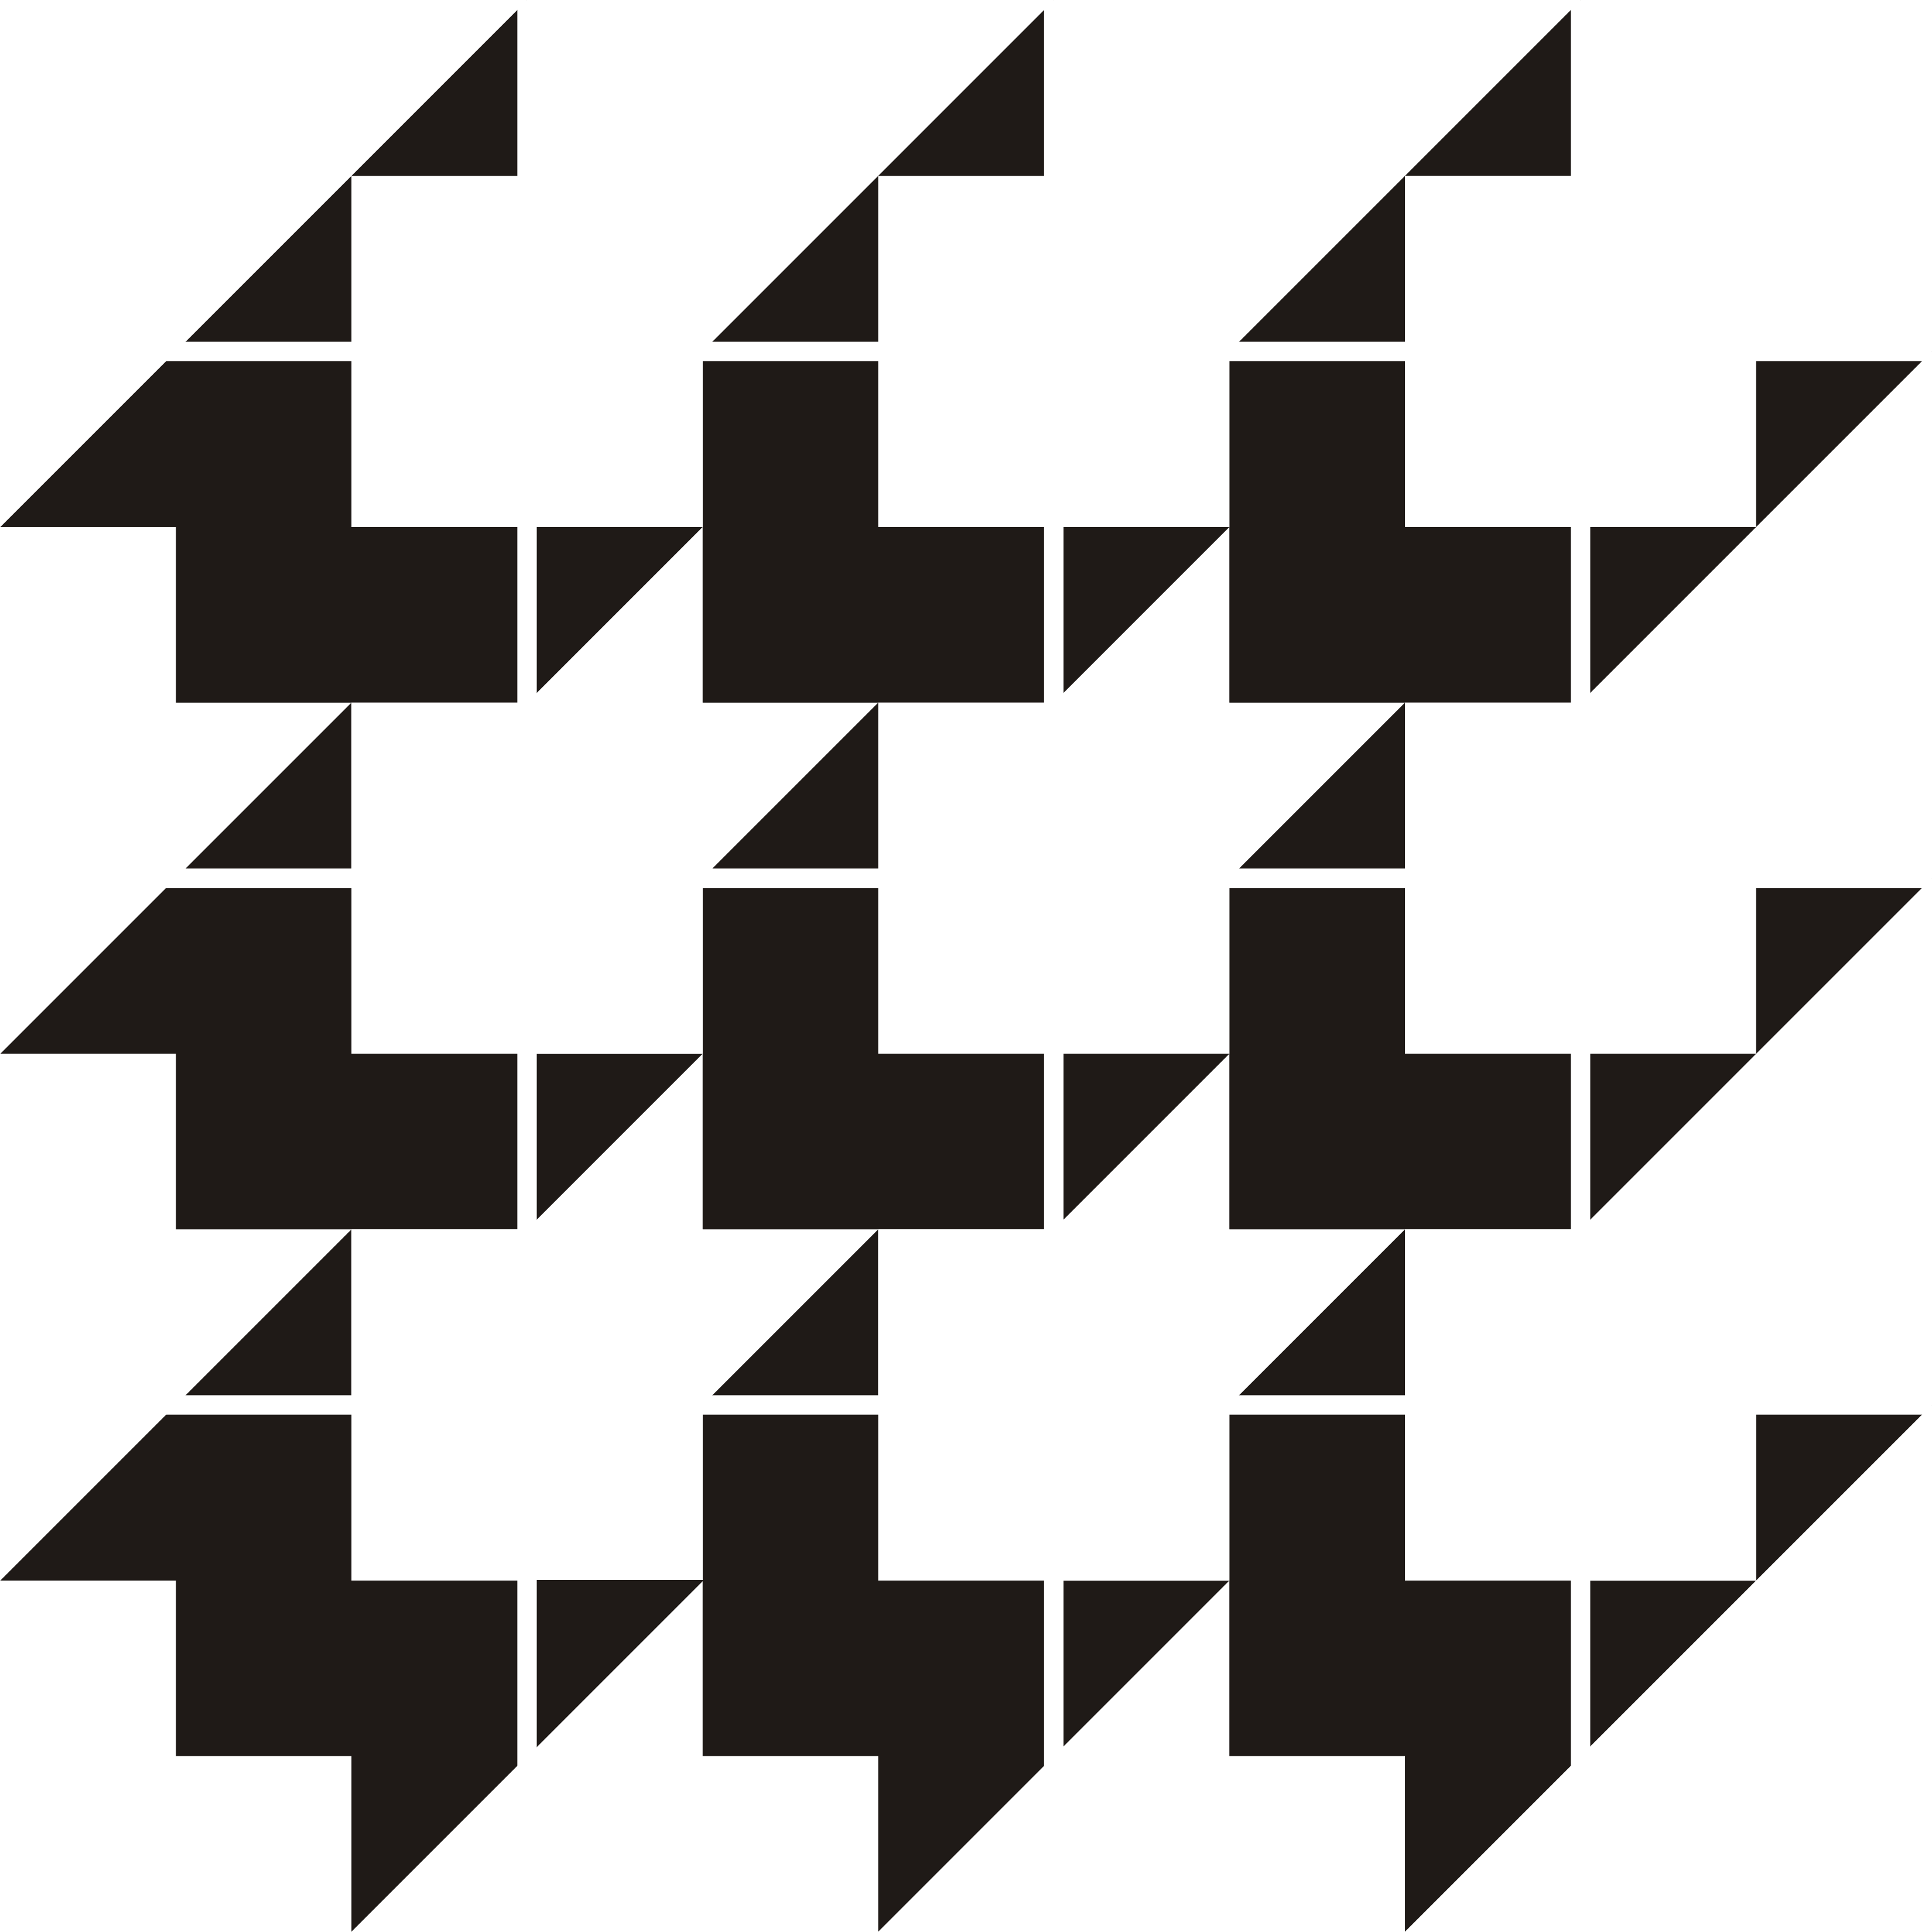
Center for Discrete Mathematics &
Theoretical Computer Science

DIMACS EDUCATIONAL MODULE SERIES

MODULE 08-5
Reconstructing Curves from Sample Data: Implementing Algorithms using Voronoi Diagrams and Delaunay Triangulations
Date Prepared: August, 2008

Pallavi Jayawant
Bates College, Lewiston, ME 04240
pjayawan@bates.edu

Martha Kosa
Tennessee Tech University, Cookeville, TN 38505
mjkosa@csc.tntech.edu

Christine Shannon
Centre College, Danville, KY 40422
shannon@centre.edu

DIMACS Center, CoRE Bldg., Rutgers University, 96 Frelinghuysen Road, Piscataway, NJ 08854-8018
TEL: 732-445-5928 • FAX: 732-445-5932 • EMAIL: center@dimacs.rutgers.edu Web: http://dimacs.rutgers.edu/

Founded as a National Science Foundation Science and Technology Center and a Joint Project of Rutgers University, Princeton University, AT&T Labs - Research, Bell Labs, NEC Laboratories America and Telcordia Technologies with affiliated members Avaya Labs, Georgia Institute of Technology, HP Labs, IBM Research, Microsoft Research, Rensselaer Polytechnic Institute, and Stevens Institute of Technology.
Module Description Information

- Title:

Reconstructing Curves from Sample Data: Implementing Algorithms using Voronoi Diagrams and Delaunay Triangulations

- Author(s):
- Pallavi Jayawant, Bates College, Lewiston, ME 04240, pjayawan@bates.edu

- Martha Kosa, Tennessee Tech University, Cookeville, TN 38505, mjkosa@csc.tntech.edu
- Christine Shannon, Centre College, Danville, KY 40422, shannon@centre.edu

- Abstract:
A polygonal reconstruction of a curve C from a set of sample points S is a graph which connects every pair of sample points that are adjacent along the original curve C and no others. Curve reconstruction has a wide variety of applications in areas such as image processing, geographic information systems, and curve fitting. This module describes a simple algorithm for curve reconstruction and gives a method to implement it. The description of the algorithm is preceded by a discussion of the topics of Voronoi diagrams and Delaunay triangulation. The implementation includes a detailed description of the necessary data structures.

- Informal Description:
In this module we describe an algorithm to reconstruct a curve from a set of sample points on the curve and then give a method to implement it. To understand the algorithm, we need to know about Voronoi diagrams and Delaunay triangulations. In Sections 2 and 3, we introduce these topics and then in Section 4 we go on to describe the algorithm. Section 5 gives resources on the World Wide Web that are relevant to the topics covered in the module. The details of the implementation of the algorithm are given in Section 6. Sections 7 and 8 describe in detail how the module can be used in a computer science or mathematics classroom.
.

- Target Audience:
Sophomore/junior computer science students or mathematics students with sufficient programming background (only necessary for implementing the algorithms)
- Prerequisites:
The discrete mathematics topics are all defined. If students are expected to implement the algorithms they will need sufficient experience with an object oriented language like Java to write the necessary code. However, all code is included for those who would merely like to study it or to experiment with it. Instructors may elect to supply a portion of the code and ask students to implement one or more classes.

- Mathematical Field:
Discrete mathematics, Computational Geometry

- Application Areas:
Computer Graphics

- Mathematics Subject Classification:
MSC (2000): 05C85, 05C90, 65D18, 68P05, 68R10, 68U05

- Contact Information:
Christine Shannon, Centre College, Danville, KY 40422, shannon@centre.edu

- Other DIMACS modules related to this module:
None

