DIMACS
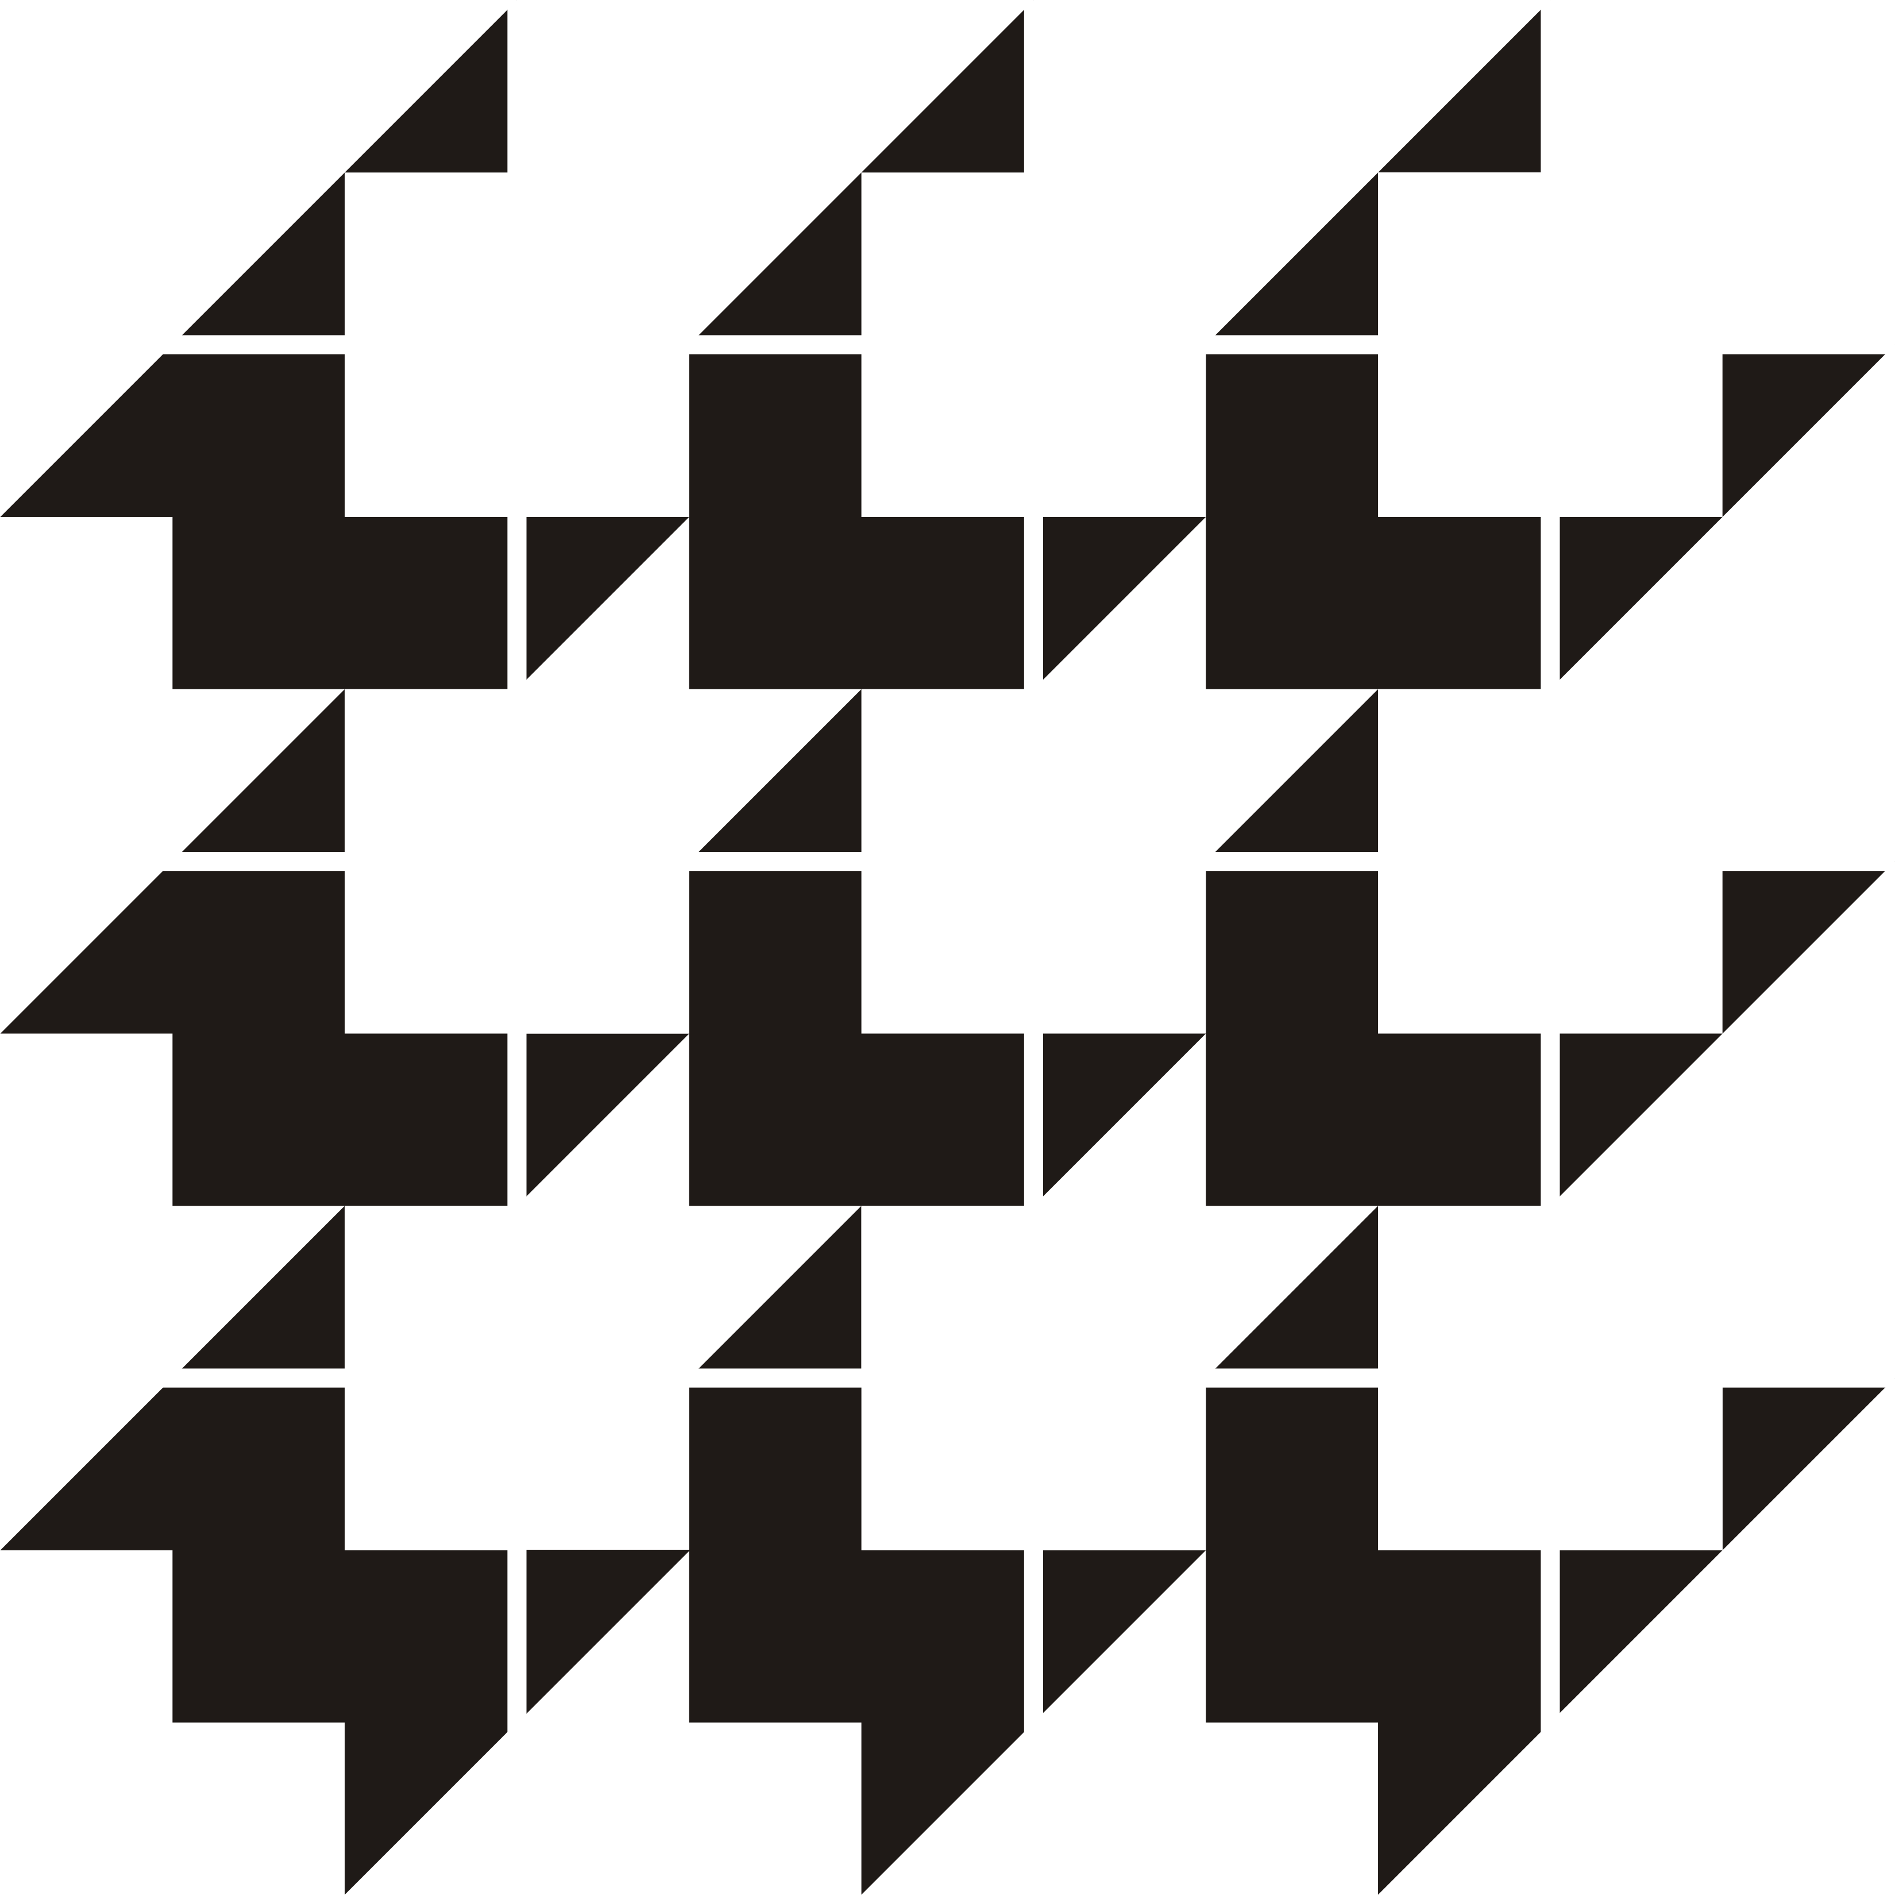
Center for Discrete Mathematics &
Theoretical Computer Science

DIMACS EDUCATIONAL MODULE SERIES

MODULE 07-3
Using Population Models in the Teaching of Eigenvalues
Date Prepared: August 2007

John Boardman
Franklin College, Franklin, Indiana 46131
jboardman@franklincollege.edu

Dan Hrozencik
Chicago State University, Chicago, Illinois 60628
dhro@att.net

Miyeon Kwon
University of Wisconsin-Platteville, Platteville, WI 53818
kwonmi@uwplatt.edu

Irfan Ul-Haq
University of Wisconsin-Platteville, Platteville, WI 53818
ulhaqi@uwplatt.edu

Aklilu Zeleke
Michigan State University, East Lansing, MI 48824
zeleke@msu.edu

DIMACS Center, CoRE Bldg., Rutgers University, 96 Frelinghuysen Road, Piscataway, NJ 08854-8018
TEL: 732-445-5928 • FAX: 732-445-5932 • EMAIL: center@dimacs.rutgers.edu Web: http://dimacs.rutgers.edu/

Founded as a National Science Foundation Science and Technology Center and a Joint Project of Rutgers University, Princeton University, AT&T Labs - Research, Bell Labs, NEC Laboratories America and Telcordia Technologies with affiliated members Avaya Labs, Georgia Institute of Technology, HP Labs, IBM Research, Microsoft Research, Rensselaer Polytechnic Institute, and Stevens Institute of Technology.

Module Description Information

- Title:

Using Population Models in the Teaching of Eigenvalues

- Author(s):
1. John Boardman, Franklin College, Franklin, Indiana 46131
jboardman@franklincollege.edu

2. Dan Hrozencik, Chicago State University, Chicago, Illinois 60628
dhro@att.net

3. Miyeon Kwon, University of Wisconsin-Platteville, Platteville, WI 53818
kwonmi@uwplatt.edu

4. Irfan Ul-Haq, University of Wisconsin-Platteville, Platteville, WI 53818
ulhaqi@uwplatt.edu

5. Aklilu Zeleke, Michigan State University, East Lansing, MI 48824
zeleke@msu.edu

- Abstract:
Leslie Matrix and Modified Leslie Matrix (Lefkovitch Matrix) are discussed in this module. These two matrices help us to discover that how the population structure changes with time. We take the approach of introducing the concepts through the real life examples i.e. we use biological data available for different populations. The examples and questions are constructed in such a way that after going through these, hopefully, the students will appreciate the importance of the eigenvalues and eigenvectors. This module can be used in a Linear Algebra class or any other appropriate level math course. A project is also added which one can use as a group project.

- Informal Description:
In this module we discuss how one can use matrix theory and eigenvalues to describe the way the population structure varies over time. We will use the real life examples (biological models) to explain and introduce concepts. In particular we will discuss two methods to study the population structure: Leslie Matrix and Modified Leslie Matrix (Lefkovitch Matrix). Leslie matrix is based on age-specific biological models while Lefkovitch matrix is based on stage-specific biological models. Exploratory exercises are presented throughout the module for the reader to work on whenever a new concept is introduced.

- Target Audience:
This module is aimed at the undergraduate students who are taking Linear Algebra, Differential Equations, Dynamical Systems or Mathematical Modeling course. Usually the students registered in these courses are at sophomore, junior or senior level.

- Prerequisites:
Basic knowledge of matrix theory like matrix operations, independent/dependent vectors, basis vectors, eigenvectors, eigenvalues and some probability theory.

- Mathematical Field:
Linear Algebra, Differential Equations, Dynamical Systems, Mathematical Modeling.

- Application Areas:
Dynamical systems, Biology, Ecology

- Mathematics Subject Classification:
MSC (2000): 37N25, 92B05, 78A70, 97D80

- Contact Information:
Irfan Ul-Haq, University of Wisconsin-Platteville, Platteville, WI 53818
ulhaqi@uwplatt.edu

- Other DIMACS modules related to this module:
None

